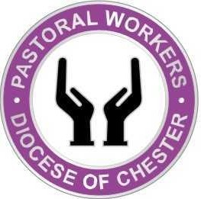

Pastoral Worker Ministry Agreement

Name of Pastoral Worker | Name of Incumbent
Name of Parish | Date of last Ministry Agreement
Date of Licensing | Renewal of Licence due
Date of most recent DBS check for licensed ministry | Dates of safeguarding training completed in the last three years
Basic:

Foundations:

Leadership:

Raising Awareness of Domestic Abuse:

This document acknowledges the discussion and agreement between the Pastoral Worker and incumbent of areas identified below. This agreement should be reviewed and updated once a year. A copy thereof will be requested by the Bishop’s Ministry Administrator whenever there is a renewal or extension of your licence, transfer or change in status such as Emeritus or PTO, for example.

The Ministry Agreement is intended to describe a working relationship, manage expectations, check assumptions and anticipate areas of tension or role conflict. It is not a contract.

Any questions or concerns should be raised at the earliest opportunity with the Bishop’s Advisers for Licensed Lay Ministers.

Primary focus of Pastoral Worker’s ministry (e.g. bereavement visiting, ministry to the sick, families and children, baptism ministry, etc) including:

- Area of responsibility/oversight:

- Services/events that the Pastoral Worker will usually attend:

- ‘Base’ church or congregation for PW ministry (if different from above):

- Expected involvement within the church/parish:

- Groups and committees the Pastoral Worker will be involved in:

- Approximate time commitment the Pastoral Worker will offer:

How often will the Pastoral Worker and Incumbent meet for supervision?

How will expenses incurred by the Pastoral Worker be agreed and claimed?

Ministerial training/development:

- Details of ministerial training/development undertaken in the last three years:

- What are the expectations for the Pastoral Worker’s ongoing training and resourcing for ministry?

- What policies and guidelines will the Pastoral Worker be expected to be aware of and abide by?

- Identified areas for personal/ministerial development:

Are there any potential issues identifiable by the Pastoral Worker or incumbent?

Proposed date to review this agreement: ______________________________________________

Pastoral Worker signature (electronic): _________________________________________________

Incumbent signature (electronic): ______________________________________________________

DATE: _______________________________________________________________________________________

Please complete the form, obtain the signature of your incumbent, scan and email the form to the Bishop’s Ministry Administrator: karen.alsop@chester.anglican.org

