
Sabbatical Policy and Process
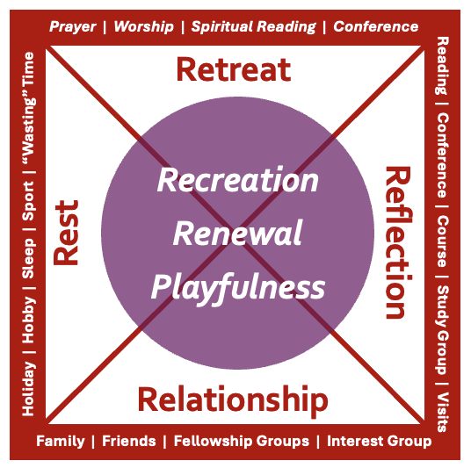
Licensed clergy are eligible to apply for a three-month sabbatical every seven years of service (with service starting after curacy has ended), so long as they have been in their present post for at least three years.
Those acting as training incumbents should not apply to take a sabbatical during the first 2 years of the curacy. It is potentially possible to split the 3 months of the sabbatical up into a number of discrete instalments.
Sabbaticals are to be approved by the senior staff at the People and Places meeting, and supported by the Ministry Team. Clergy will normally produce a written report and will be invited to present a 10-15 minute summary of their sabbatical experience at a bi-annual post-sabbatical seminar facilitated by the Ministry Team where senior diocesan staff may be present.
Limited financial support is available on a first come first served basis. Stipendiary clergy are normally eligible for these grants. SSOMs may apply where costs are incurred and there is wider benefit to their ministry.
Process
- Initial contact with Ministry Team to discuss process and timescales, and to check if sabbatical grant available for the proposed year.
- Incumbent or Ministry team check with suffragan bishop – initial expression of interest and proposed timescale.
- Check with Wardens and PCC; inform rural dean of proposed dates.
- Meeting with Ministry Team on framing ideas and completing form.
- Complete form and send to suffragan (copied to Ministry team); suffragan takes it to People & Places.
- If P&P approves, email to Ministry Team to confirm approval of sabbatical.
- Ministry Team arranges payment of grant at appropriate time.
- Sabbatical …
- Sabbatical report is produced and sent to suffragan (copied to Ministry team) within 3 months of the sabbatical’s conclusion.
- Invited to present at post-sabbatical seminar.
Factors clergy must consider
Be aware that ministers in receipt of stipend support from sector posts may not be entitled to in-service sabbaticals for that part of their appointment.
Clergy taking a sabbatical should:
- Obtain the support of the wardens and PCC(s) – and make sure they understand that the PCC will be responsible for paying any fees or travel expenses that the covering of services whilst you are away will require. Clarify who is arranging the cover and when.
- If it would help to have someone from the Ministry team talk through how sabbaticals work and their advantages with your PCC or Wardens, do get in touch.
- If you live in a vicarage:
  - When you are due to take your sabbatical leave, you should notify the Property Department of the dates so any planned works or statutory requirements (eg Gas Safety Inspections) can be scheduled and organized appropriately.
  - You should also provide the Property Dept with contact information for someone who has access / keys to the house in case of emergencies should the sabbatical involve the house being left unoccupied for a period of time. This would usually be a Churchwarden or family member.
  - If the house is to be left unoccupied for more than 28 days consecutively, then you must make arrangements for the house to be inspected weekly, for insurance purposes.

