
Sabbatical Application Form
For Licensed Clergy

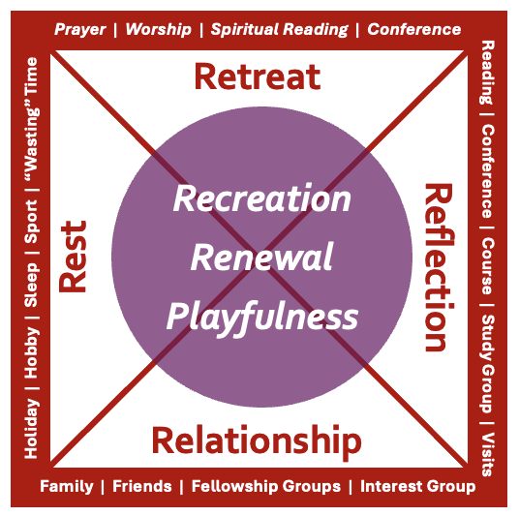

In submitting this form, you confirm that your application confirms to the Sabbatical Policy and Procedures (available on Sabbatical pages of Diocesan website). Please read these carefully before submission.

Completed claim forms should be emailed to: ministry@chester.anglican.org

Name
Phone number
Email address
Present appointment (including parish no.)
Number of years in post:
Date of application |  | Date of last sabbatical
I have the support of wardens and PCC | Yes/No | I will not have a curate in the first 2 years of their post
I wish to apply for a sabbatical grant of £300 |  |  | Yes/No
I wish to apply for a CMD grant of up to £250 |  |  | Yes/No
Please give details of what funding will cover:

Please give details of any other sources of funding identified:

FOR OFFICE USE ONLY
Expected form of reporting: | Written report:  Seminar presentation:
Authorised: | Date:

SABBATICAL PLANS
You may find it useful to work with the resources in the appendices for you planning before committing them to writing in the boxes below.

Note for the diligent: not every question needs an answer, they are helpful prompts not an exam.
Rationale – what is the overall aim of the sabbatical?
What is the overall rationale for (or aim of) the sabbatical in one sentence?
(experience suggests that answering this question is one of the most helpful bits of preparation you can do)

……………………
  - What habits will you look to develop that serve this aim?
  - How do the plans developed below serve this aim?
  - How will the fruits and learnings that come from this be shared?

a)
b)
c)

Rest – what part does recharging and refreshing play?
What does ‘rest’ look like?
  - What is your daily and weekly pattern of rest going to be?
  - You should plan take between one and three weeks additional holiday as part of the sabbatical: tell us about these plans.
  - How will you invest in your own health (spiritually, mentally, physically, and emotionally) during this time?

a)
b)
c)

Retreat – when, where and how will you do this?
How will you retreat?
  - How will your daily pattern have space for you to invest in your devotional life?
  - Where and how will you join in fellowship and worship?
  - What role will spiritual accompaniment or direction play in this?
  - Where, when, and how will you take a retreat in this time?
a)
b)
c)
d)

Reflection – how will you structure your thinking and praying?
What part does formal or semi-formal reflection take in your sabbatical planning and how will this be of benefit to you and the ministry to which you are called?
  - Are you undertaking formal study, and if so, how does this fit into the overall healthy shape of this sabbatical?
    - Where is the research dynamic of reflection?
    - How will this be shared?
  - If you are not undertaking formal study:
    - What do you plan to read? And how does this serve your overall aim?
    - From whom do you hope to learn? And how does this serve your overall aim?
    - Who will sharpen your thinking or learning? And how does this serve your overall aim?
    - Which conference or learning event/s do you intend to attend? And how does this serve your overall aim?
    - How will you record and share the fruits of your reflection?

a)
b)

Relationship – how will this sabbatical be a relational blessing?
How will you invest in relationship in this sabbatical?
  - How will you invest in family and friends in an intentional manner?
  - Where will you seek fellowship?
  - Where else do you need to invest during this time and how will you do so.

a)
b)
c)

Re-entry – how will you transition back into ‘normal life’ and allow the sabbatical to bear fruit?
Thinking of re-entry, how will the sabbatical end, and what plans do you foresee for sharing its fruit?
  - What will you need to do before the end of the sabbatical to be ready to return?
  - How might ‘normal’ look different when your return?
  - What do you anticipate you might have to share
    - in your ministry context?
    - more widely?

a)
b)
c)

Appendix A

The Sabbatical elements diagram
If you think visually then scribble on the pictures – what goes in the four triangles that make up the box? This is the ‘What’ of the sabbatical and can capture what you plan to do.
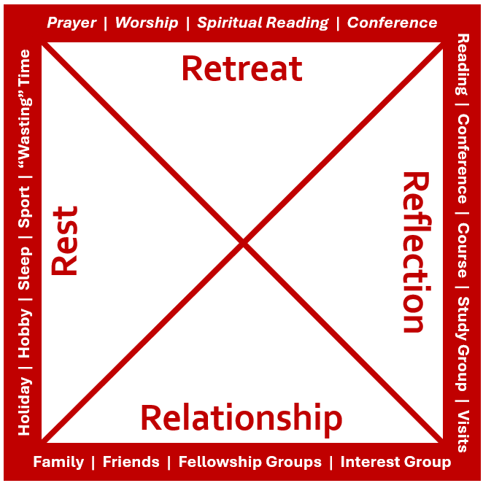

And what fills the circle? This is the ‘How’ of the sabbatical and can capture something of the mood and deeper purpose of the sabbatical.
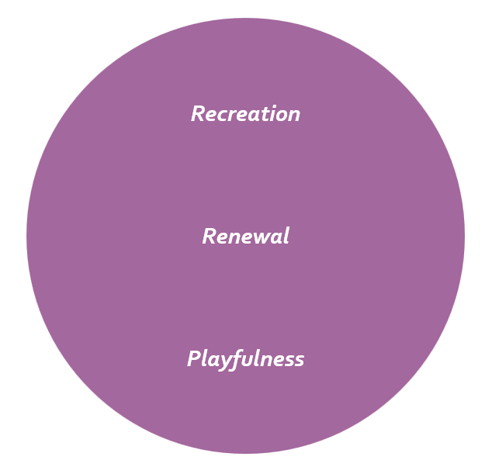

How do the two fit together? Is there a harmony between the What and the How? Where is the circle placed in relation to the boundary elements? How do the What and the How meet the ‘Why’ – the rationale – of the sabbatical?

Appendix B

A helpful grid
This set of questions will help you to reflect at the end of your sabbatical (and may form the basis of a written sabbatical report). It can also be really helpful to work through this in the planning stage.

 | God | Neighbour (especially family) | Self
Heart | How has this deepened my relationship with God? | With whom (and how) have I refreshed or established relationship? | How have I attended to my emotional wellbeing?
Soul | How has this refreshed my discipleship? | Where have I prayed, worshipped, learned, laughed, and wept with others? | How have I attended to my spiritual wellbeing?
Mind | Where have I reflected and learned about faith? | What insights have I gained about doing life well and healthy exercise of ministry? | How have I attended to my mental wellbeing?
Strength | What practices, habits, disciplines, or insights have I developed to enable me to follow Christ more freely? | What have I taken time to do with others? | How have I attended to my physical wellbeing?

